CSC505 Module 1 Critical Thinking

Michael McPherson
Colorado State University, Winter-B
CSC505-1 Principles of Software Development
Module 1
Dr Douglas Mujeye

15 December 2024
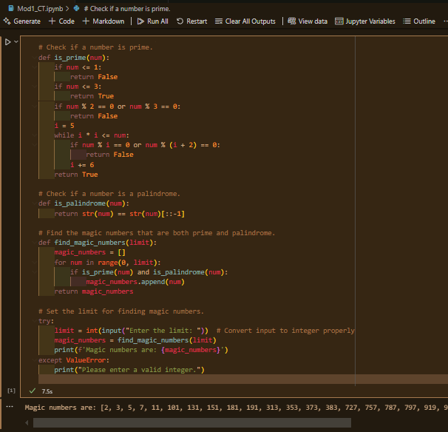
- To get familiar with Python programming and its related Integrated Development Environment (IDE), begin by writing a simple Python script with any desired functionality.
Questions:
- Next, answer the following questions. Write out both the question and your answer:
  - Why does it take so long to get software finished?
    - Software development requires many different processes, the general steps are: Planning, Designing, Coding, Testing and deployment.
    - Each of these processes have their own difficulties each of which may cause a delay in the deliverables. During the testing stage, testers work to see if the various parts of the code work seamlessly with one another. If there is an error in one line of the code, then you may run into a situation of the entire system not working. Finding the error can be very tedious and time consuming effort. This will affect the deliverable timeline and the launch.
  - Why are development costs so high?
    - The complexity of current software systems requires vast knowledge of a wide variety of experts all working together to produce the software.
    - Another reason costs in software development can be high is that most software projects are done using an agile approach. Due to the iterative nature and the built in feedback loops, which are key parts of this approach often increase the time line as new requirements and refinements come to light.
  - Why can't we find all errors before we give the software to our customers?
    - There is no cost effective or feasible way to prevent all errors and bugs before release. Some of the bugs will only be found during actual use of the software, and only then, when a very specific set of conditions have occurred in the right order for the software to fail.

  - Why do we spend so much time and effort maintaining existing programs?
    - Maintenance is a critical part of any product line. Just like car manufacturers may take weeks, months or years to recognize that there is a flaw in the design or production of their final product, software packages may also have flaws/bugs.
  - Why do we continue to have difficulty in measuring progress, as software is being developed and maintained?
    - Even when the software development is managed under and iterative agile approach, the actual development is not linear. You can have many teams working on varying levels of the software that are not connected or in serial. For example, Team A could be building the main functions that build the initial dataset, while Team G is working on building the UX/UI.

References
Hoy, Z., & Xu, M. (2023). Agile Software Requirements Engineering Challenges-Solutions—A Conceptual Framework from Systematic Literature Review. Information, 14(6), 322. https://doi.org/10.3390/info14060322
IEEE. (n.d.). Challenges in agile software development: A systematic literature review. IEEE Xplore. Retrieved December 15, 2024, from https://ieeexplore.ieee.org/document/7872736
Pressman, R., & Maxim, B. (2020). Software engineering: A practitioner’s approach (9th ed.). McGraw-Hill Education. ISBN-13: 9781259872976

